SOURCE CODE

import java.util.Scanner;

public class CalculateTheQuotient {

public static void main(String[] args) {

Scanner scanner = new Scanner(System.in);

System.out.println("Enter two integer numbers: ");

int num1 = scanner.nextInt();

int num2 = scanner.nextInt();

int quotient = num1 / num2 ;

int remainder = num1 % num2;

System.out.println("The quotient is of " + num1 + " and " + num2 + " is: " + quotient + " and the remainder of " + num1 + " and " + num2 +

" is: " + remainder);

}

}

OUTPUT

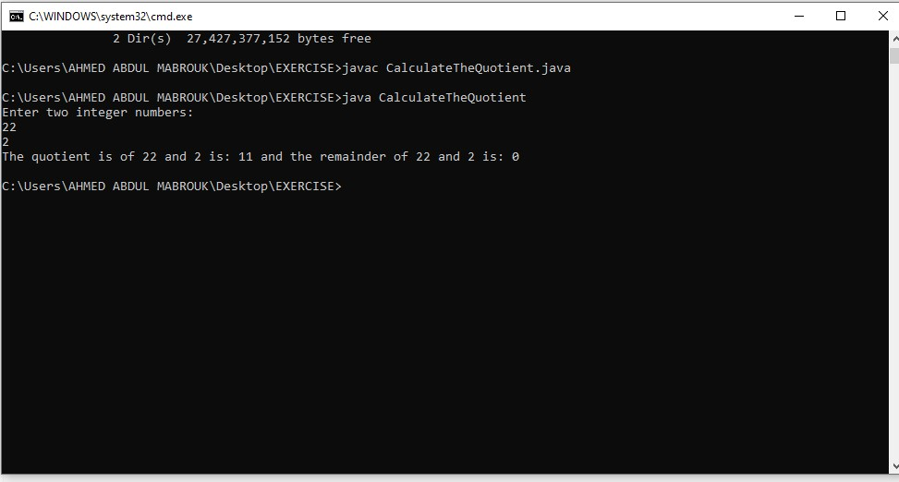

SOURCE CODE:

import java.util.Scanner;

public class CelsiusToFahrenheitTempConverter {

public static void main(String[] args) {

Scanner scanner = new Scanner(System.in);

System.out.println("Enter a temperature in Celsius: ");

double tempCelsius = scanner.nextDouble();

double Fahrenheit = 1.8 \* tempCelsius + 32;

System.out.println("The temperature converted to Fahrenheit is: " + Fahrenheit);

}

}

OUTPUT:

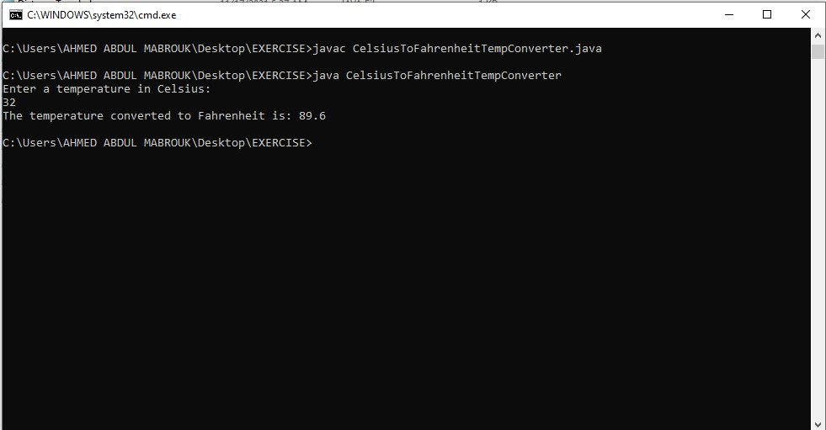

SOURCE CODE:

import java.util.Scanner;

public class DistanceTraveled {

public static void main(String[] args) {

Scanner scanner = new Scanner(System.in);

System.out.println("Enter Speed/Miles: ");

int speed = scanner.nextInt();

System.out.println("Enter Time/Hours: ");

int time = scanner.nextInt();

int distance = (60 \* time);

System.out.println("The distance the car will travel in " + time + " hours is: " + distance);

}

}

OUTPUT:

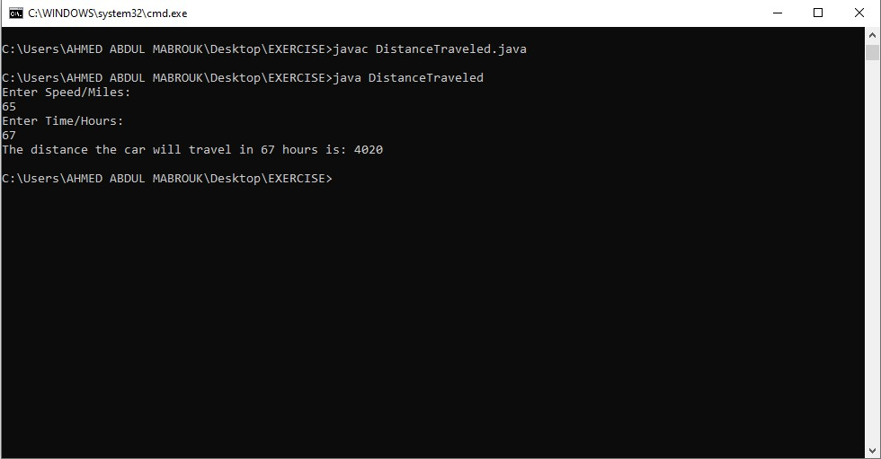

SOURCE CODE:

import java.util.Scanner;

public class FirstNameLastName {

public static void main(String[] args) {

Scanner scanner = new Scanner(System.in);

System.out.println("Enter first name: ");

String firstName = scanner.next();

System.out.println("Enter last name: ");

String lastName = scanner.next();

System.out.println("Welcome " + firstName + " " + lastName + "!");

}

}

OUTPUT:

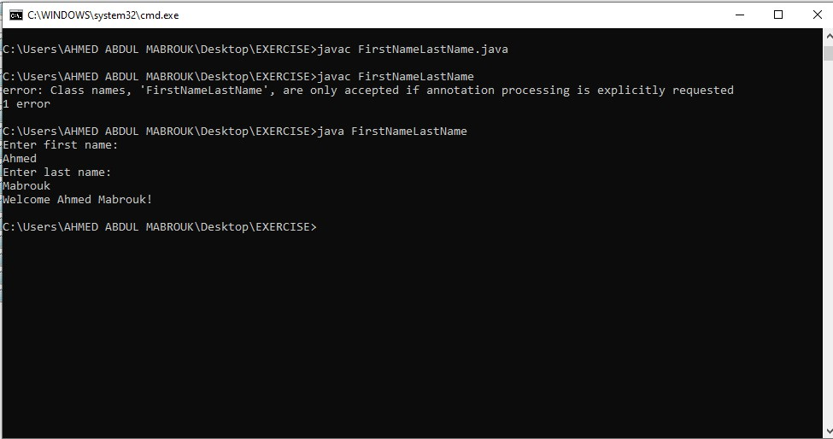

SOURCE CODE:

import java.util.Scanner;

public class LandCalculation {

public static void main(String[] args) {

Scanner scanner = new Scanner(System.in);

System.out.println("Enter the total square feet: ");

int squareFeet = scanner.nextInt();

int numberOfAcre = (squareFeet / 43560);

System.out.println("The number of acres in the tract is: " + numberOfAcre);

}

}

OUTPUT:

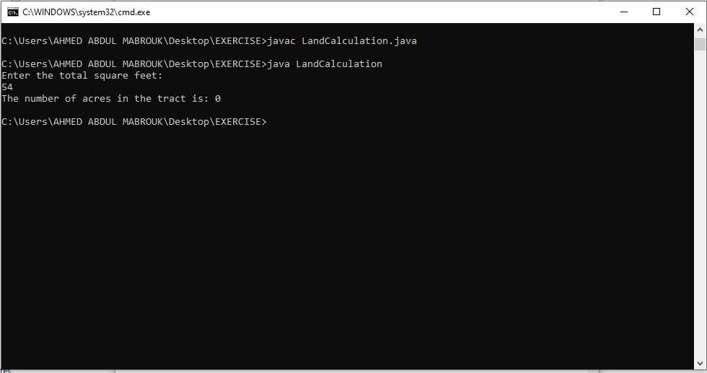

SOURCE CODE:

import java.util.Scanner;

public class MilesPerGallon {

public static void main(String[] args) {

Scanner scan = new Scanner(System.in);

System.out.println("Enter number of miles: ");

double miles = scan.nextDouble();

System.out.println("Enter number of gas gallons: ");

int gasGallons = scan.nextInt();

double MPG = (miles / gasGallons);

System.out.println("A car miles-per-gallon (MPG) is: " + MPG);

}

}

OUTPUT:

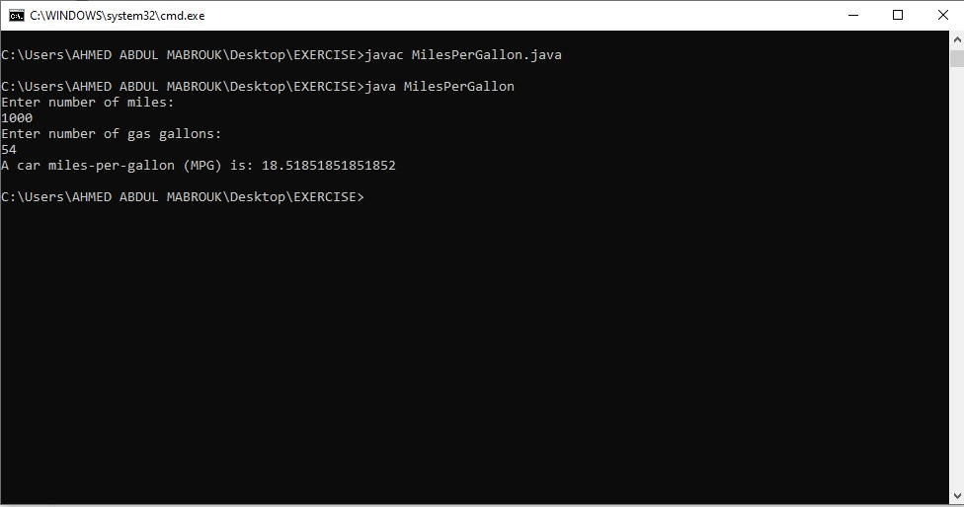

SOURCE CODE:

public class PersonalInfo {

public static void main(String[] args) {

String name = "Ahmed";

String address = "Tomondo";

String city = "Zanzibar";

String ZIP = "Tm-003";

double telephoneNo = 0779075930;

String collegeMajor = "Suza";

System.out.println("My name is: " + name + "\nMy address is: " + address + " which is located at the city of: " + city + " which goes by " +

" ZIP code of: " + ZIP + "\nMy telephone number is: " + telephoneNo + " and my college major is: " + collegeMajor);

}

}

OUTPUT:

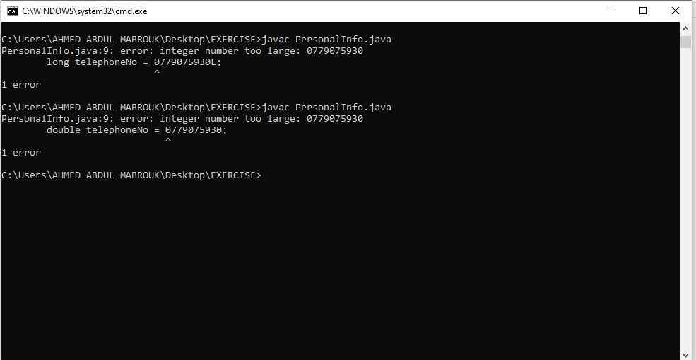

SOURCE CODE:

import java.util.Scanner;

public class Qn12 {

public static void main(String[] args) {

Scanner scanner = new Scanner(System.in);

System.out.println("Enter two numbers: ");

int num1 = scanner.nextInt();

int num2 = scanner.nextInt();

int sum = (num1 + num2);

int product = (num1 \* num2);

int difference = (num1 - num2);

int quotient = (num1 / num2);

System.out.println("The sum is: " + sum + "\nThe product is: " + product + "\nThe difference is: " + difference + "\nThe quotient is: " + quotient);

}

}

OUTPUT:

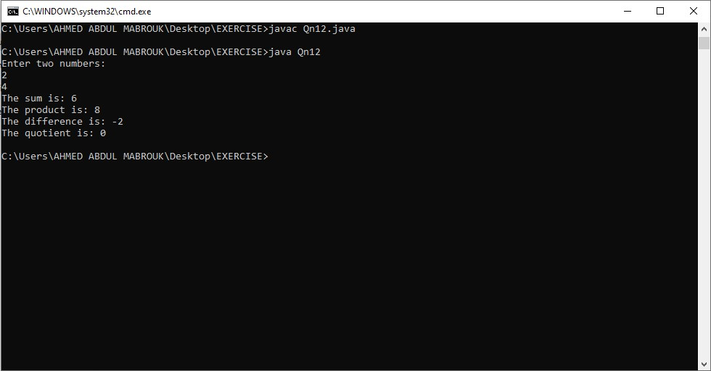

SOURCE CODE:

import java.util.Scanner;

public class Qn15 {

public static void main(String[] args) {

Scanner scanner = new Scanner(System.in);

System.out.println("Enter first name: ");

String firstName = scanner.next();

System.out.println("Enter last name: ");

String lastName = scanner.next();

System.out.println("Enter your age in year: ");

int age = scanner.nextInt();

System.out.println("Welcome " + firstName + " " + lastName + "! You are " + age + " seconds old!");

}

}

OUTPUT:

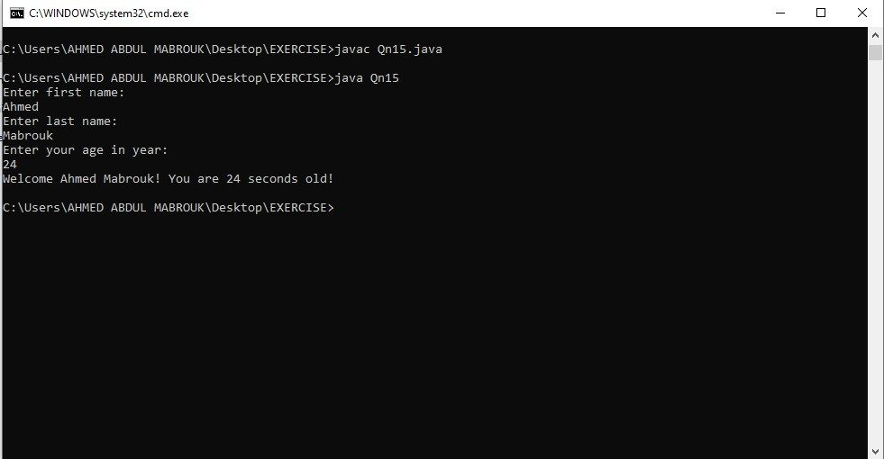

SOURCE CODE:

import java.util.Scanner;

public class SalesPrediction {

public static void main(String[] args) {

Scanner scanner = new Scanner(System.in);

System.out.println("Please Enter the projected amount of total sales: ");

double amountTotalSale = scanner.nextInt();

double profit = (amountTotalSale \* 0.23);

System.out.println("The profit that is made from your amount is: " + profit);

}

}

OUTPUT:

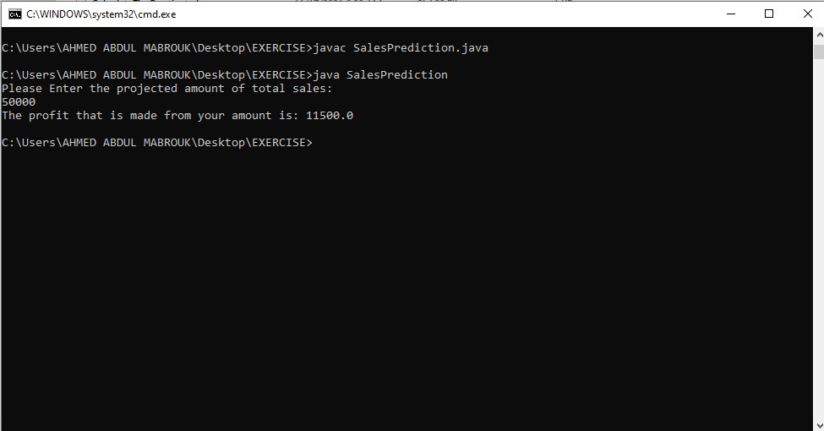

SOURCE CODE:

import java.util.Scanner;

public class SalesTax {

public static void main(String[] args) {

Scanner scan = new Scanner(System.in);

System.out.println("Enter the amount of a purchase: ");

int purchase = scan.nextInt();

System.out.println("The amount of purchase is: " + purchase);

double stateSalesTax = (purchase \* 0.04);

System.out.println("the state sales tax is: " + stateSalesTax);

double countrySalesTax = (purchase \* 0.02);

System.out.println("The county sales tax is: " + countrySalesTax);

double totalSalesTax = (stateSalesTax + countrySalesTax);

System.out.println("The total sales tax is: " + totalSalesTax);

double totalOfTheSale = (purchase + totalSalesTax);

System.out.println("Tnd the total of the sale is: " + totalOfTheSale);

}

}

OUTPUT:

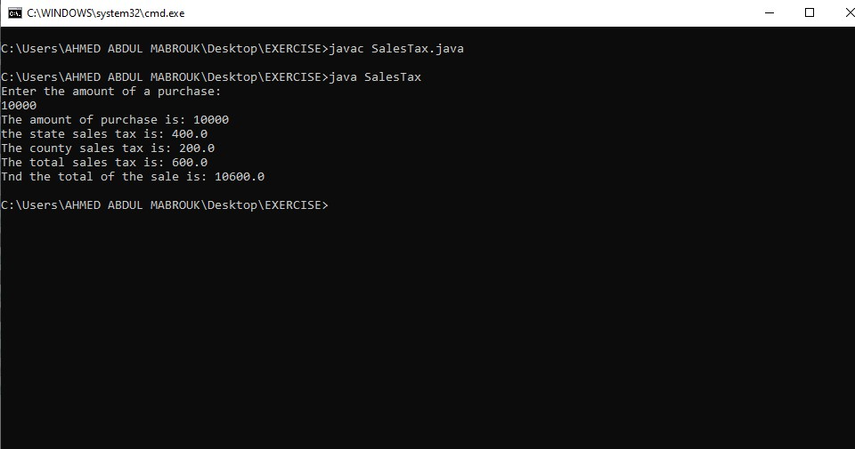

SOURCE CODE:

import java.util.Scanner;

public class SalesTax {

public static void main(String[] args) {

Scanner scan = new Scanner(System.in);

System.out.println("Enter the amount of a purchase: ");

int purchase = scan.nextInt();

System.out.println("The amount of purchase is: " + purchase);

double stateSalesTax = (purchase \* 0.04);

System.out.println("the state sales tax is: " + stateSalesTax);

double countrySalesTax = (purchase \* 0.02);

System.out.println("The county sales tax is: " + countrySalesTax);

double totalSalesTax = (stateSalesTax + countrySalesTax);

System.out.println("The total sales tax is: " + totalSalesTax);

double totalOfTheSale = (purchase + totalSalesTax);

System.out.println("Tnd the total of the sale is: " + totalOfTheSale);

}

}

OUTPUT:

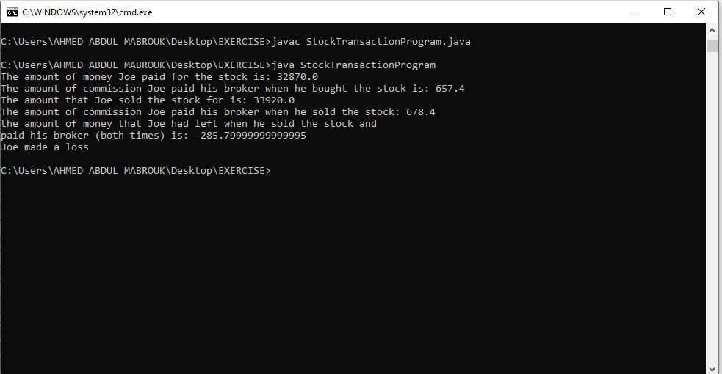

SOURCE CODE:

import java.util.Scanner;

public class TipTaxTotal {

public static void main(String[] args) {

Scanner scanner = new Scanner(System.in);

System.out.println("Enter the charge for the food: ");

int charges = scanner.nextInt();

double tip = (charges \* 0.15);

double saleTax = (charges \* 0.07);

double total = (charges + tip + saleTax);

System.out.println("The ampount Tip is: " + tip + "\nThe sales tax is: " + saleTax + "\nThe total cost is: " + total);

}

}

OUTPUT:

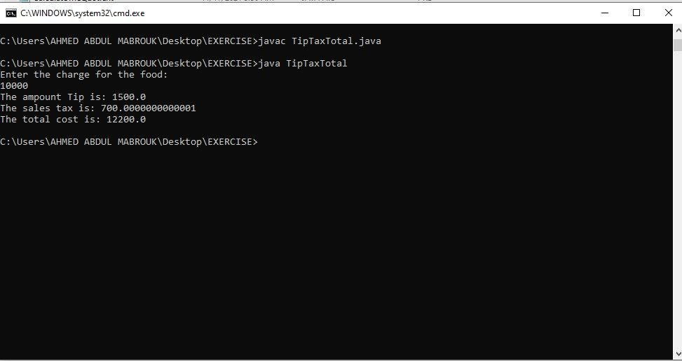

SOURCE CODE:

import java.awt.event.ComponentAdapter;

import java.util.Scanner;

public class TotalPurchase {

public static void main(String[] args) {

Scanner scanner = new Scanner(System.in);

int subTotal = 0;

double salesTax;

double total;

boolean shouldFinish = false;

while (shouldFinish != true) {

System.out.println("Enter the price of item 1: ");

int item1 = scanner.nextInt();

System.out.println("Enter the price of item 2: ");

int item2 = scanner.nextInt();

System.out.println("Enter the price of item 3: ");

int item3 = scanner.nextInt();

System.out.println("Enter the price of item 4: ");

int item4 = scanner.nextInt();

System.out.println("Enter the price of item 5: ");

int item5 = scanner.nextInt();

shouldFinish = true;

subTotal = (item1 + item2 + item3 + item4 + item5);

}

System.out.println("The subtotal of the sale is: " + subTotal);

salesTax = (subTotal \* 0.06);

System.out.println("The amount of sales tax is: " + salesTax);

total = (subTotal + salesTax);

System.out.println("The total cost is: " + total);

}

}

OUTPUT:

